“Process Termination Message System”
A Project Report Submitted in the partial fulfillment of the requirements for the award of the degree of

BACHELOR OF TECHNOLOGY
In

DEPARTMENT OF COMPUTER SCIENCE ENGINNERING

By

ALLURU AMULYA 2520030032

CH GAYATRI SRI HARSHITA 2520030600

KUNAL SHAHANE 2520030275

Under the Esteemed Guidance of

Dr. K. Hema
Assistant Professor
Department of Computer Science and Engineering




K L (Deemed to be) University DEPARTMENT OF COMPUTER SCIENCE ENGINEERING
&

DEPARTMENT OF COMPUTER SCIENCE AND INFORMATION TECHNOL

Declaration

The Project Report entitled “Process Termination Message System” is a record of Bonafide work of ALLURU AMULYA-2520030032 , CH GAYATRI SRI HARSHITA-2520030600, KUNAL SHAHANE-2520030257 submitted in
partial fulfillment for the award of B. Tech in Computer Science and Engineering to the K L University. The results embodied in this report have not been copied from any other departments/University/Institute.

ALLURU AMULYA 2520030032

CH GAYATRI SRI HARSHITA 2520030600

KUNAL SHAHANE 2520030275

K L (Deemed to be) University

DEPARTMENT OF COMPUTER SCIENCE ENGINEERING

CERTIFICATE

This is certify that the mini project based report entitled “Process Termination Message System” is a bonafide work done and submitted by ALLURU AMULYA-2520030032 , CH GAYATRI SRI HARSHITA-2520030600, KUNAL SHAHANE-2520030257
in partial fulfillment of the requirements for the award of the degree of BACHELOR OF TECHNOLOGY in Department of Computer Science Engineering, K L (Deemed to be University), during the academic year 2026-2027.

Signature of the Guide

Signature of the Course Coordinator Signature of the HOD

ACKNOWLEDGEMENT
The success in this project would not have been possible but for the timely help and guidance rendered by many people. Our wish to express my sincere thanks to all those who has assisted us in one way or the other for the completion of my project.

Our greatest appreciation to my Course Coordinator Dr. K. Anusha, and my guide Dr. K.Hema, Department of Computer Science which cannot be expressed in words for his/her tremendous support, encouragement and guidance for this project.

We express our gratitude to Dr. P Venkateshwara Roa (CSE), Head of the Department for Computer Science Engineering for providing us with adequate facilities, ways and means by which we are able to complete this project-based Lab.

We thank all the members of teaching and non-teaching staff members, and also who have assisted me directly or indirectly for successful completion of this project. Finally, I sincerely thank my parents, friends and classmates for their kind help and cooperation during my work.

ALLURU AMULYA 2520030032

CH GAYATRI SRI HARSHITA 2520030600

KUNAL SHAHANE 2520030275

Abstract

Process Termination Message System is a Linux-based systems programming project designed to monitor and manage the termination of child processes created by a parent application and provide meaningful termination information to the parent process. In a system where multiple child processes perform different tasks, it is important for the parent process to determine when each child completes its assigned operation and whether the termination occurred normally or abnormally. The proposed system creates multiple child processes using the fork() system call, where each child is assigned a specific service-oriented task. These tasks include data processing, file backup, network service handling, database operations, and security monitoring. Each child performs its respective operation using Linux file handling, process-management, and signal-related APIs before terminating.

The parent process acts as a process monitor and uses the waitpid() system call to detect child process termination and collect the corresponding termination status. For every child process, the system records and displays important process information such as the Process ID (PID), Parent PID, termination type, exit status, or terminating signal. Normal child termination is identified using WIFEXITED() and its exit status is obtained using WEXITSTATUS(). In the case of abnormal termination, the system uses WIFSIGNALED() and WTERMSIG() to identify the signal responsible for termination. The network service specifically demonstrates signal-based abnormal termination by generating a SIGTERM signal, allowing the parent process to detect and report the abnormal termination. The system also demonstrates zombie-process handling by intentionally delaying waitpid() for the network service, allowing the terminated child to temporarily exist as a zombie before the parent reaps it using waitpid(). This provides a practical demonstration of process synchronization, termination-status collection, signal handling, and proper child-process cleanup.

Overall, the Process Termination Message System provides a practical demonstration of important Operating System and Systems Programming concepts through actual Linux process execution rather than simple message simulation. The individual child services perform real operations such as creating and processing data files, copying and verifying backup files, creating and testing a TCP socket connection, inserting, reading, updating, and verifying database records stored in a file, and scanning the Linux /proc filesystem for active processes. The parent process maintains an event history and provides termination reports and process statistics, including normal terminations, signal-based terminations, process reaping, and zombie handling. Through these operations, the project demonstrates process creation, parent-child relationships, inter-process synchronization, exit status management, signal-based termination, zombie-process prevention, and process lifecycle management. It therefore provides a practical understanding of how Linux creates, executes, monitors, terminates, and cleans up child processes while communicating meaningful termination information to their parent process.

Index

S. No. | Chapter | Topics / Subtopics | Page No.
 | Acknowledgement |  | i
 | Abstract |  | ii
1 | Introduction |  | 8-12
 |  | 1.1 Background of the Project
 |  | 1.2 Problem Statement
 |  | 1.3 Scope of the Project
 |  | 1.4 Objectives of the Project
 |  | 1.5 Importance of the Application
 |  | 1.6 Target Users / Audience
2 | OS Concepts and Background Study |  | 13-16
 |  | 2.1 Operating System Concepts Related to the Project
 |  | 2.2 Existing Methods / Algorithms
 |  | 2.3 Proposed Approach
 |  | 2.4 Advantages of the Proposed Approach
3 | System Requirements |  | 16–20
 |  | 3.1 Hardware Requirements
 |  | 3.2 Software Requirements
 |  | 3.3 Operating System Environment – Ubuntu / WSL
 |  | 3.4 Development Tools and Compilers
4 | Technology and Tools Used |  | 21–25
 |  | 4.1 C / C++ Programming
 |  | 4.2 GCC Compiler
 |  | 4.3 Linux System Calls
 |  | 4.4 POSIX Threads / Synchronization
 |  | 4.5 Linux Commands and Utilities
 |  | 4.6 Other Tools / Libraries Used
5 | System Architecture and Design |  | 26–30
 |  | 5.1 Overall System Architecture
 |  | 5.2System Workflow
 |  | 5.3 Flowchart / Data Flow
 |  | 5.4 Module Description
 |  | 5.5 Input and Output Design
6 | Implementation |  | 31–44
 |  | 6.1 Module-wise Implementation
 |  | 6.2 Algorithm / Pseudocode
 |  | 6.3 Core C / C++ Implementation
 |  | 6.4 Linux System Calls / APIs Used
 |  | 6.5 Process / Thread Implementation
 |  | 6.6 IPC / Synchronization Implementation
 |  | 6.7 Memory Management Implementation
 |  | 6.8 Optional User Interface Implementation
7 | Execution and Demonstration |  | 45–53
 |  | 7.1 Compilation in Ubuntu
 |  | 7.2 Execution Commands
 |  | 7.3 Sample Inputs and Outputs
 |  | 7.4 Screenshots of Execution
 |  | 7.5 Demonstration of OS Concepts
8 | Conclusion |  | 54–59
 |  | 8.1 Summary of the Project
 |  | 8.2 Objectives Achieved
 |  | 8.3 Results Achieved
 |  | 8.4 Skills and Learning Outcomes
9 | References |  | 60–63
 |  | 9.1 Books
 |  | 9.2 Research Papers
 |  | 9.3 Linux / GNU Documentation
 |  | 9.4 Online Resources

CHAPTER -1 INTRODUCTION

Background of the Project
In modern operating systems, a single application may need to perform multiple tasks simultaneously or independently. To manage such tasks efficiently, the operating system provides a process-based execution mechanism in which a parent process can create and manage multiple child processes. Each child process can be assigned a specific task and can execute independently while maintaining a parent-child relationship with the process that created it. Monitoring the lifecycle of these child processes is important because the parent process needs to know when a child has completed its task, how it terminated, and whether any abnormal termination occurred.
The Process Termination Message System is developed to demonstrate this process-management mechanism in a practical Linux environment. The system uses the fork() system call to create child processes, with each child performing a different service-oriented operation. The implemented services include Data Processing, File Backup, Network Service, Database Service, and Security Monitoring. After completing their respective operations, the child processes terminate and communicate their termination status to the parent process through the operating system. The parent uses waitpid() to collect this information and analyzes the returned status using functions such as WIFEXITED(), WEXITSTATUS(), WIFSIGNALED(), and WTERMSIG().
A major focus of the project is the proper management of terminated child processes. If a parent does not collect the termination status of a completed child, the terminated process can remain temporarily as a zombie process. Therefore, the project includes a specific demonstration in which the Network Service child is terminated using SIGTERM, while the parent intentionally delays waitpid() to demonstrate the temporary zombie state before subsequently reaping the child. The project therefore provides a practical background for understanding process creation, parent-child relationships, process termination, exit status, signal handling, synchronization, waitpid(), and zombie-process prevention in Linux. These concepts form the foundation of the Process Termination Message System and directly support the project's stated objectives and methodology.

  - Problem Statement
When an application creates multiple child processes to perform different tasks, the parent process needs to know when each child process terminates and whether the termination was normal or abnormal. Without proper termination-status handling, the parent cannot obtain meaningful information about the outcome of the child process.
Another important problem is the proper management of terminated child processes. If the parent process does not collect the termination status of a completed child, the child may remain in the system as a zombie process. Therefore, the parent must use mechanisms such as wait() or waitpid() to detect child termination, collect the termination status, and properly reap the terminated process.
The Process Termination Message System addresses these problems by creating multiple child processes, assigning different tasks to them, and allowing the parent process to monitor their execution and termination. The system identifies the child's PID, determines whether it terminated normally or through a signal, reports the relevant termination information, and demonstrates proper zombie-process prevention through waitpid(). This provides a practical implementation of process creation, termination detection, synchronization, and parent-child process management in Linux.
  - Scope of the Project
The scope of the Process Termination Message System is to develop a Linux-based C application that creates, executes, monitors, and manages multiple child processes. Each child process is assigned a different service-oriented task, while the parent process acts as the central monitor responsible for tracking the execution and termination of these processes. The project focuses on demonstrating practical process-management concepts rather than simply displaying simulated messages.
The major areas covered by the project include:
- Process Creation: Creating child processes using fork().
- Task Execution: Assigning different tasks to individual child processes.
- Process Monitoring: Tracking child PID and parent PID information.
- Termination Detection: Using waitpid() to detect child termination.
- Termination Analysis: Identifying normal and abnormal termination.
- Exit Status Handling: Using WIFEXITED() and WEXITSTATUS().
- Signal Handling: Detecting signal-based termination using WIFSIGNALED() and WTERMSIG().
- Service Operations: Performing data processing, file backup, network, database, and security-monitoring tasks.
The project mainly focuses on how the parent process manages the child processes and obtains meaningful information about their termination. After a child completes its assigned task, the parent uses waitpid() to collect its termination status. The system records information such as the child PID and parent PID and determines whether the child terminated normally or abnormally. For normal termination, the exit status is displayed, while for signal-based termination, the corresponding signal information is reported. The project also includes a specific network-service scenario in which SIGTERM is used to demonstrate abnormal termination.
An important part of the scope is demonstrating zombie-process handling and proper process cleanup. During the network service event, the parent temporarily delays waitpid() so that the terminated child can exist as a zombie, after which the parent calls waitpid() to reap and resolve it. The system also provides an event history and process statistics through its report center, helping users understand the execution and termination results of different services. Overall, the project is limited to demonstrating process creation, parent-child execution, termination-status collection, synchronization, signal handling, and zombie-process prevention using C programming and Linux/POSIX system calls.

1.4 Objectives of the Project
The primary objective of the Process Termination Message System is to provide a practical implementation of Linux process management concepts through the creation and monitoring of child processes. The system is designed so that each child process performs a specific task, while the parent process monitors its execution and collects meaningful information when the child terminates. This helps demonstrate how the operating system manages the complete lifecycle of processes.
The project focuses on creating independent child processes and assigning different service-oriented operations to them. The parent process maintains control over these processes and receives their termination information after execution. The major objectives include:
- Creating and executing multiple child processes with different assigned tasks.
- Monitoring the termination of each child process using waitpid().
- Identifying normal and abnormal termination along with the relevant status information.
- Demonstrating signal-based termination and temporary zombie-process handling.
- Providing termination reports and process statistics for monitoring the executed events.
Another important objective is to understand how termination information is communicated from a child process to its parent. The system uses WIFEXITED() and WEXITSTATUS() to identify normally completed processes and obtain their exit codes. For abnormal termination, WIFSIGNALED() and WTERMSIG() are used to identify the signal responsible for terminating the child. The project particularly demonstrates SIGTERM through the Network Service, providing a practical example of signal-based process termination.
Finally, the project aims to demonstrate proper process synchronization and resource management. The parent process collects the termination status of completed children using waitpid() so that terminated processes do not remain as zombies. The report center further helps in viewing the latest event, executed-event history, and overall process statistics. Through these objectives, the project provides practical understanding of process creation, parent-child relationships, termination handling, synchronization, signal handling, and zombie-process prevention in a Linux environment.

  - Importance of the Application
The Process Termination Message System is important because it provides a practical demonstration of how Linux manages child processes and communicates their termination information to the parent process. In a system where multiple child processes perform different tasks, the parent needs to monitor their execution and identify whether they have terminated normally or abnormally. The application demonstrates the use of fork() for process creation and waitpid() for collecting termination status, along with PID, exit status, and signal information.
The application is also important for understanding process synchronization and zombie-process prevention. By properly collecting the termination status of child processes, the parent can ensure that terminated processes are reaped and do not remain as zombies. The project further demonstrates these concepts through practical tasks such as data processing, file backup, network service handling, database operations, and security monitoring. Thus, it provides a practical understanding of parent-child process relationships, termination handling, signal-based termination, synchronization, and process lifecycle management in Linux.
  - Target Users / Audience
The Process Termination Message System is mainly designed for students and learners who are studying Operating Systems and Systems Programming. The application provides a practical way to understand how processes are created, executed, monitored, and terminated in a Linux environment. Instead of learning these concepts only through theory, users can observe the execution of multiple child processes and the way the parent process receives their termination information.
The system is particularly useful for Operating System students, Systems Programming learners, programming students, faculty members, and project evaluators. Students can use it to understand process creation using fork(), synchronization using waitpid(), exit-status handling, signal-based termination, and zombie process prevention. Faculty can use the application as a practical demonstration of parent-child process relationships and process lifecycle management.

CHAPTER -2 SYSTEM REQUIREMENTS

2.1 Operating System Concepts Related to the Project

The Process Termination Message System is based on fundamental Operating System concepts related to process management and process lifecycle. In a Linux environment, a process represents a running program and may create other processes to perform separate tasks. The project demonstrates how a parent process creates and manages multiple child processes and monitors their execution until they terminate. The major concepts involved are process creation, parent-child relationship, process execution, process termination, and process synchronization. These concepts are implemented practically using C programming and Linux system calls.

The project uses the fork() system call as the main mechanism for process creation. When the parent process calls fork(), a new child process is created and both processes continue execution independently. Each process is identified using a unique Process ID (PID), while the Parent Process ID (PPID) identifies the relationship between the child and its parent. In this project, multiple children are created and each child performs a different service-oriented task. The important concepts demonstrated are:

Process Creation using fork() – creates independent child processes from the parent.

Process Identification – uses PID and parent PID to identify process relationships.

Process Execution – each child performs a specific task before termination.

Process Termination – children terminate after completing their assigned operations.

Process Synchronization – the parent uses waitpid() to coordinate with child termination.

Another major concept is process termination and synchronization. After completing its task, a child process terminates and provides an exit status to the operating system. The parent process uses waitpid() to wait for the child and collect this status. The project uses WIFEXITED() to determine whether the child terminated normally and WEXITSTATUS() to obtain the exit value. Different service processes return different exit values, allowing the parent to identify and report the result of each completed operation.

The project also demonstrates signal-based termination, which occurs when a process is terminated because of a signal rather than completing normally. The network service intentionally generates SIGTERM using raise(SIGTERM). The parent detects this condition using WIFSIGNALED() and obtains the signal number using WTERMSIG(). This provides a practical understanding of the difference between normal process termination and abnormal termination caused by a signal.

Finally, the project demonstrates zombie process prevention and proper process cleanup. After a child terminates, the parent must collect its termination information so that the terminated process does not remain as a zombie. The project temporarily delays waitpid() for the network-service event to demonstrate this behavior and subsequently reaps the child using waitpid(). Thus, the project combines process creation, execution, synchronization, termination, signal handling, and zombie prevention into one practical Linux application.

2.2 Existing Methods / Algorithms

Traditional Linux process-management methods provide standard mechanisms for creating and controlling processes. The fork() system call is commonly used to create a child process from a parent process, after which the child can execute its assigned program or operation. Once the child completes execution, the parent can use wait() or waitpid() to wait for the child and collect its termination status. These system calls form the basic foundation for synchronization between parent and child processes and are widely used in systems programming.

The existing termination-status mechanism determines how a child process completed its execution by examining the status returned by the operating system. For normal termination, WIFEXITED() checks whether the child completed normally and WEXITSTATUS() obtains the value returned by the child. For abnormal termination, WIFSIGNALED() checks whether a signal caused the termination and WTERMSIG() identifies the signal responsible. These mechanisms provide the parent with essential information about the child's execution.

Common existing mechanisms include:

fork() for creating a child process.

wait() for waiting for a terminated child.

waitpid() for waiting for a specific child process.

Exit status checking for identifying normal completion.

Signal status checking for identifying abnormal termination.

Another important existing method is the handling of terminated child processes. When a child finishes execution, the operating system retains certain information about that child until its parent collects the termination status. If the parent does not perform a waiting operation, the child may remain in the process table as a zombie process. Existing systems therefore use wait() or waitpid() to collect the child's status and allow the operating system to remove the terminated process information.

Although these existing methods are effective for process management, basic implementations generally demonstrate them using simple child processes that perform limited operations. The focus is normally on showing how fork(), wait(), or waitpid() work rather than demonstrating several different types of child activities within one system. As a result, learners may understand individual system calls but may not get a complete practical view of how process execution, termination, signals, and zombie prevention can work together.

The proposed project builds upon these established Linux mechanisms rather than replacing them. The existing methods provide the necessary foundation for process creation, termination-status collection, signal identification, and zombie prevention. The project extends their practical use by assigning different tasks to multiple child processes and presenting their termination information through a structured monitoring and reporting system.

2.3 Proposed Approach

The proposed approach develops a Process Termination Message System in which a parent process creates and monitors multiple child processes performing different tasks. The main purpose is to provide meaningful information about how each child process terminates. Instead of creating children only for demonstration purposes, the system assigns an actual service-oriented operation to each child. This allows the complete process lifecycle to be observed from creation and execution to termination and reaping.

The system contains five child-process activities, with each child responsible for a specific operation. The services include data processing, file backup, network service, database service, and security monitoring. The data-processing child calculates statistical values from records, the file-backup child copies data into a backup file, and the database child performs record operations. The network child performs a local connection attempt and demonstrates abnormal termination, while the security-monitoring child scans Linux process information through /proc.

The proposed system follows a structured process-monitoring approach. The major components of the approach are:

Multiple Child Processes: Each child performs a separate service-oriented task.

Parent Monitoring: The parent records the PID and parent PID of every child.

Status Analysis: The parent determines whether each child terminated normally or abnormally.

Signal-Based Termination: The network service intentionally uses SIGTERM to demonstrate abnormal termination.

Process Reporting: Termination information is organized into latest-event reports, event history, and process statistics.
After the child processes perform their respective tasks, the parent process uses waitpid() to collect their termination information. The returned status is analyzed to determine whether the process completed normally or was terminated by a signal. The parent records important details such as the child PID, parent PID, termination type, exit status, and signal number. The system also includes a temporary delay for the network-service event to demonstrate the behavior of a terminated child before it is reaped. Once waitpid() is executed, the child is properly collected, preventing it from remaining as a zombie.
The proposed approach also includes a practical demonstration of zombie process handling. For the network event, the parent intentionally waits for a short period before calling waitpid(), allowing the temporary zombie condition to be observed. The parent then collects the child's termination status and reaps the process. The system records the execution and termination information in reports and provides latest-event, event-history, and process-statistics options. Therefore, the proposed approach integrates multiple child activities, process monitoring, termination analysis, signal handling, synchronization, and zombie prevention into a single application.

2.4 Advantages of the Proposed Approach

The proposed approach provides a practical and structured way to understand process management in a Linux environment. Instead of demonstrating process creation and termination only through simple statements, the system creates multiple child processes and assigns each one a meaningful task. This allows users to observe how different processes execute independently while the parent process continues to monitor their activities and termination.

One major advantage is that the system demonstrates different process termination conditions within the same application. Most child processes complete their assigned tasks and return specific exit statuses, while the network service demonstrates abnormal termination using SIGTERM. The important information collected by the parent includes:

Process ID and Parent Process ID

Normal or abnormal termination status

Exit status or terminating signal

Reaping status of the child process

The proposed approach also improves the understanding of process synchronization and zombie process prevention. The parent uses waitpid() to collect the termination status of each child after its execution. In the network-service event, a temporary delay is introduced before waitpid() so that the behavior of a terminated child can be demonstrated. The child is then properly reaped, showing how zombie processes can be prevented through correct parent-process management.

Another advantage is that the system provides organized monitoring and reporting instead of displaying termination information only once on the screen. The application maintains event information and provides latest-event reports, event history, and process statistics. This makes it easier for students and evaluators to observe the complete process lifecycle and understand how concepts such as process creation, execution, synchronization, signal-based termination, and zombie prevention work together in a real Linux-based application.

CHAPTER-3 SYSTEM REQUIREMENTS

3.1 Hardware Requirements

3.2 Software Requirements

3.3 Operating System Environment – Ubuntu / WSL

The Process Termination Message System is developed and executed in a Linux-based environment, with Ubuntu serving as the primary operating system environment. Ubuntu provides the system-level facilities required for process creation, process execution, synchronization, termination, signal handling, file operations, and socket programming. Since the project uses Linux/POSIX system calls such as fork() and waitpid(), Ubuntu provides a suitable environment for implementing and testing the complete process lifecycle.

The project can also be executed using Windows Subsystem for Linux (WSL), which provides a Linux environment within the Windows operating system. WSL allows users to work with Ubuntu commands and Linux development tools without requiring a separate physical Linux installation. The required C source files can be compiled using the GCC compiler and executed through the Ubuntu terminal. The environment supports important project operations such as process creation using fork(), synchronization using waitpid(), signal-based termination using SIGTERM, and process monitoring through the /proc filesystem.

Ubuntu/WSL is particularly suitable for this project because several components depend directly on Linux functionality. The security-monitoring service accesses /proc to obtain information about active processes, while the network service uses Linux socket facilities to perform its connection operation. The parent process uses Linux process-management mechanisms to collect child termination information and prevent zombie processes. Therefore, Ubuntu/WSL provides the necessary operating system environment for compiling, executing, testing, and demonstrating the complete Process Termination Message System in a practical Linux environment.

3.4 Development Tools and Compilers

The Process Termination Message System is developed using the C programming language because C provides direct access to operating system facilities and system calls. The project uses C to implement process creation, child-process execution, termination handling, synchronization, file operations, socket programming, and process monitoring. The programs are divided into separate source files for different services, while main.c controls the creation and monitoring of the child processes.

The main development tools and compilation facilities used in the project are Ubuntu/WSL, GCC compiler, Linux Terminal, and a text/code editor. Ubuntu or WSL provides the Linux environment required for executing system-level operations, while GCC is used to compile the C source files into an executable program. The Linux terminal is used to compile, execute, and observe the output of the application during testing.

The project uses the following important development components:

C Language – used for implementing all process and service operations.

GCC Compiler – compiles the C source files into an executable program.

Ubuntu / WSL Terminal – provides the Linux environment for execution.

Code Editor – used to create and modify the C source files.

Linux System Libraries – provide functions for processes, signals, files, sockets, and system information.

The GCC compiler is particularly important because the project contains multiple C source files that must work together. The files for data processing, file backup, network service, database service, security monitoring, and the main process-monitoring program are compiled together to produce the final executable. During compilation, the required Linux header files and libraries provide access to functions such as fork(), waitpid(), socket(), signal operations, file handling, and directory operations.

The development environment also supports testing and debugging of the process-management features. The program can be executed from the Ubuntu terminal, where the user can observe child PIDs, parent PIDs, service execution, normal exit statuses, signal-based termination, and zombie-process handling. Thus, the selected development tools and compiler provide a simple and suitable environment for implementing, compiling, testing, and demonstrating the project.

CHAPTER 4: TECHNOLOGY AND TOOLD USED

4.1 C / C++ Programming

The Process Termination Message System is primarily developed using the C programming language because C provides direct access to operating system-level functions and Linux system calls. C is widely used in Operating Systems and Systems Programming for implementing process creation, process management, synchronization, signals, file handling, and other low-level operations. In this project, C is used to create child processes, execute their assigned tasks, monitor their termination, and provide meaningful termination information to the parent process.

The project is divided into multiple C source files to keep the implementation organized and easier to manage. The main program main.c controls the overall process execution, while separate files handle data processing, file backup, network service, database service, and security monitoring. Important C and Linux functions such as fork(), waitpid(), exit(), raise(), file-handling functions, socket functions, and directory operations are used according to the requirements of each service. This modular use of C allows every child process to perform a specific operation before reporting its termination to the parent.

Although the section is titled C / C++ Programming, the actual implementation of this project is done using C programming only. C is suitable for the project because it provides direct interaction with Linux process-management mechanisms and makes Operating System concepts easier to demonstrate at the system level. Through C, the project implements process creation, execution, synchronization, normal and abnormal termination, signal handling, and zombie process prevention, thereby providing a practical implementation of the concepts studied in Operating Systems and Systems Programming.

4.2 GCC Compiler

The GNU Compiler Collection (GCC) is used to compile and execute the C programs developed for the Process Termination Message System. GCC provides a suitable compilation environment for Linux-based system programming because it supports standard C programming along with Linux system calls and libraries. The project source files such as main.c, data_processing.c, file_backup.c, network_service.c, database_service.c, and security_monitoring.c are compiled using GCC to produce an executable program.

GCC is important in this project because the program uses several operating-system-level functions that must be compiled and linked correctly. Functions such as fork(), waitpid(), exit(), raise(), socket operations, file handling functions, and directory operations are supported through the required Linux header files and libraries. GCC converts the source code into machine-executable instructions so that the parent and child processes can be created and executed properly. The compilation process also helps identify syntax errors, missing declarations, and other programming errors before execution.

The compiled program is executed through the Linux terminal, where the different child services can be selected and monitored. During execution, GCC-compiled code allows the system to display process IDs, parent process IDs, normal exit statuses, signal-based termination information, and zombie-process handling results. Thus, GCC acts as the main compiler for transforming the project's C source files into an executable Linux application and supports the practical demonstration of process creation, termination, synchronization, and signal handling.

4.3 Linux System Calls

Linux system calls are an important part of the Process Termination Message System because they provide an interface between the application program and the Linux operating system. Through these calls, a C program can request the operating system to perform specific operations that cannot be handled only through normal programming instructions. In this project, Linux system calls and related system-level functions are used for creating processes, managing parent-child relationships, synchronizing processes, handling termination, working with files, using signals, and accessing process information. This makes the application closely related to the core concepts of operating systems and systems programming.

The most important process-management calls used in the project are fork() and waitpid(). The fork() system call is used by the parent process to create a separate child process, after which the child performs its assigned service independently. The waitpid() call is then used by the parent to wait for the termination of a specific child and collect the information associated with its completion. The project also uses exit() to return a termination status from each service and raise() to intentionally generate SIGTERM in the network service. These operations allow the program to demonstrate both normal and abnormal process termination in a controlled manner.

Linux system-level functions are also used by the individual child services to perform meaningful tasks instead of simply printing messages. The data-processing service performs file operations, the file-backup service reads and writes backup files, the network service uses socket-related operations, the database service performs file-based record operations, and the security-monitoring service accesses the Linux /proc directory to obtain process information. After a child terminates, the parent analyzes the status returned by waitpid() using macros such as WIFEXITED(), WEXITSTATUS(), WIFSIGNALED(), and WTERMSIG(). Therefore, Linux system calls provide the foundation for demonstrating process creation, process synchronization, termination status, signal handling, file operations, process monitoring, and zombie process prevention in the project.

4.4 POSIX Threads / Synchronization

POSIX (Portable Operating System Interface) provides standards and programming interfaces for developing applications that interact with operating systems. In the Process Termination Message System, the main focus is on process synchronization rather than POSIX threads. The parent process must coordinate with its child processes and wait for their completion before collecting and displaying their termination information. This synchronization ensures that the parent receives the correct status of each child and maintains proper control over the process lifecycle.

The project uses waitpid() as the primary synchronization mechanism between the parent and child processes. After creating a child using fork(), the parent waits for that particular child to finish using waitpid(). The returned status is then analyzed to determine whether the child completed normally or was terminated by a signal. This mechanism prevents the parent from moving ahead without receiving the required termination information.

The synchronization process can be summarized through the following operations:

Process Creation: Parent creates a child using fork().

Process Execution: Child performs its assigned service.

Process Waiting: Parent waits using waitpid().

Status Collection: Parent collects and analyzes the child's termination status.

Process Reaping: Terminated child is properly removed from the process table.

Although the project heading includes POSIX Threads, the implementation does not create multiple threads using functions such as pthread_create(). Instead, it demonstrates process-based synchronization using Linux/POSIX process-management functions. The project also demonstrates zombie prevention by temporarily delaying waitpid() for the network service and then reaping the terminated child. Thus, synchronization ensures proper coordination between parent and child processes, accurate termination reporting, and prevention of unwanted zombie processes.

4.5 Linux Commands and Utilities

Linux commands and utilities are used throughout the development, compilation, execution, and testing of the Process Termination Message System. Since the project is developed using C in a Linux environment such as Ubuntu or WSL, the terminal provides a simple way to compile source files, execute the application, inspect generated files, and observe process-related information. These utilities support the practical development of the project and make it easier to verify whether the child processes and their assigned services are functioning correctly.

Basic Linux commands are useful for managing the project files and compiling the program. Commands such as cd are used to move between project directories, while ls is used to view source files and generated output files. The gcc command is used to compile the multiple C source files into an executable program, and the executable is started from the terminal. Commands such as cat can be used to view the contents of generated reports and log files created by the different child services. These commands help in checking the actual output produced during program execution.

Linux process utilities are particularly useful for understanding and verifying the process-management concepts demonstrated by the project. Commands such as ps can be used to view running processes and their process IDs, while kill can be used to send signals to processes when required during testing. The /proc filesystem can also be inspected to obtain process-related information, which is directly relevant to the security monitoring service in the project. Therefore, Linux commands and utilities support file management, compilation, program execution, process monitoring, output verification, and system-level testing, making them an important part of the development environment.

4.6 Other Tools / Libraries Used

Apart from the GCC compiler and Linux system calls, the Process Termination Message System uses several standard C libraries and Linux-supported libraries to implement the required functionality. These libraries provide predefined functions for file handling, process management, signals, sockets, directory operations, and input/output operations. Using standard libraries reduces the need to implement low-level functionality manually and allows the project to interact effectively with the Linux operating system.

The project uses libraries such as stdio.h for file and console input/output operations, stdlib.h for functions such as exit(), and unistd.h for process-related and Linux system functions. The sys/wait.h library provides functions and macros required for waiting for child processes and analyzing their termination status. The signal.h library is used for signal-related operations such as SIGTERM and raise(). Other libraries such as sys/socket.h, netinet/in.h, arpa/inet.h, dirent.h, and string.h support socket communication, IP address handling, directory scanning, and string processing.

These tools and libraries are used according to the requirements of the individual child services. The data-processing and file-backup services mainly use file-handling functions, the network service uses socket-related libraries, the database service uses file and string operations, and the security-monitoring service uses directory and /proc related operations. Together, these standard libraries provide the functionality required to perform actual tasks in each child process while allowing the parent process to monitor their completion and termination status.

CHAPTER -5 SYSTEM ARCHITECTURE AND DESIGN

5.1 Overall System Architecture

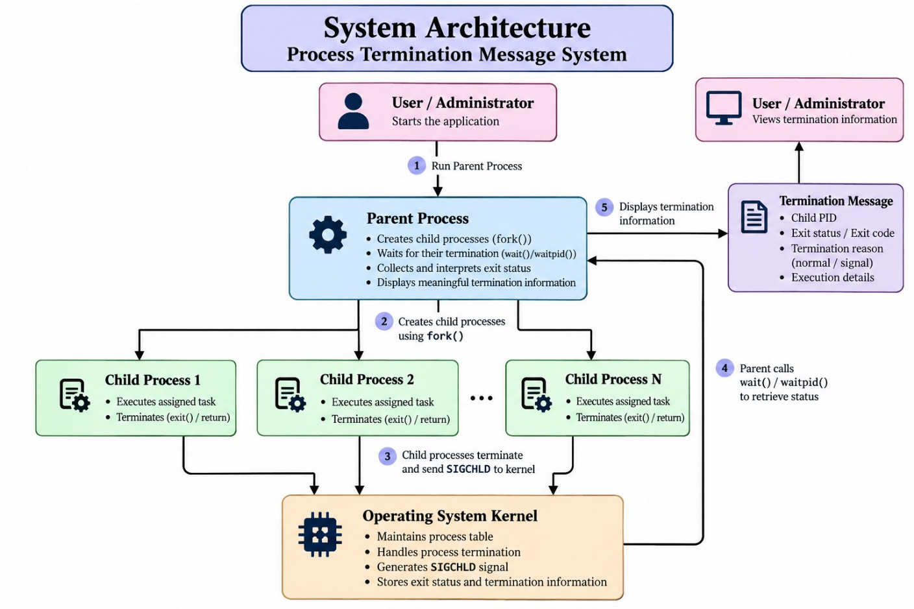

5.2 System Workflow

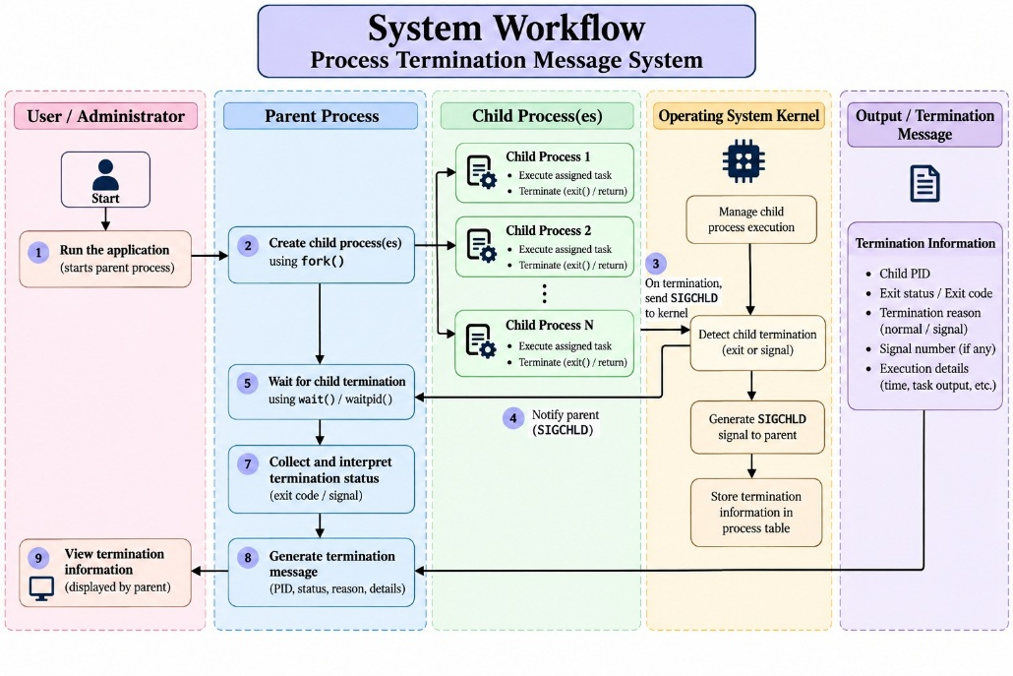

5.3 Flowchart / Data Flow

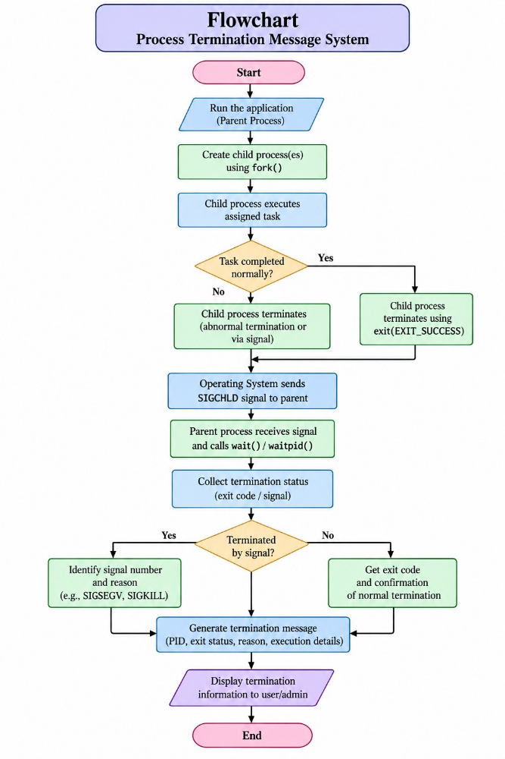

5.4 Module Description

The Process Termination Message System is developed by applying the operating system concepts covered under the six course outcomes. The project mainly focuses on process creation, process control, synchronization, signals, termination status, memory management, file systems, and concurrency concepts. The following modules describe how the project relates to the course syllabus.

Module 1: Operating System and System Call Environment – CO-1

This module focuses on the operating system as a service layer between the application program and the hardware. The project is implemented in a Linux environment using C programming and GCC. Linux system calls and library functions are used to perform process creation, process termination, file operations, socket operations, and process monitoring. The project demonstrates how a user-space program interacts with the operating system through system-level functions such as fork(), waitpid(), exit(), and signal-related operations. The terminal-based command interface also demonstrates the role of the shell in executing the application.

Module 2: Process Creation and Process Control – CO-2

This is the core module of the project and directly implements the process concepts covered in CO-2. The parent process creates multiple child processes using the fork() system call. Each child process performs a different task such as data processing, file backup, network service, database operations, or security monitoring. The parent process maintains control over the child processes and monitors their execution. The project also demonstrates process life-cycle concepts including creation, execution, synchronization, termination, and reaping of child processes.

Module 3: Process Synchronization and Signals – CO-3

This module focuses on synchronization between the parent and child processes and the handling of process termination signals. The parent process uses waitpid() to wait for the completion of its child processes and collect their termination information. The project also demonstrates signal-based abnormal termination through SIGTERM, which is intentionally generated in the network service using raise(SIGTERM). The parent identifies whether the child terminated normally or because of a signal using WIFEXITED(), WEXITSTATUS(), WIFSIGNALED(), and WTERMSIG(). This module demonstrates practical process synchronization, signal handling, and termination management.

Module 4: Memory Management and Process Address Space – CO-4

This module relates the project to memory-management concepts such as virtual memory, process address space, dynamic memory allocation, and copy-on-write behavior. Each child process created using fork() operates within its own process address space. The project demonstrates the operating system's role in maintaining separate execution environments for parent and child processes. The service modules use variables, arrays, buffers, file structures, and other temporary data during execution. Proper termination and resource handling ensure that process resources are released when the child processes finish their assigned operations.

Module 5: File Systems and File I/O – CO-5

This module focuses on Linux file systems, file abstractions, file descriptors, and file input/output operations. Several project services use file operations as part of their assigned tasks. The data processing module creates and reads data_records.txt and generates a processing report. The file backup module creates a source file and copies its contents into a backup file using fread() and fwrite(). The database service stores and updates records in a file, while the network and security services generate log and report files. Therefore, the project provides practical implementation of Linux file handling and file-based data management.

Module 6: Concurrency and Synchronization – CO-6

This module focuses on concurrency, synchronization, race conditions, and process coordination. Although the project does not use POSIX threads, it demonstrates concurrency through multiple child processes executing different service tasks. The parent process coordinates these child processes using waitpid() and ensures that their termination status is properly collected. The intentional delay in the network service provides a practical demonstration of a temporary zombie process before the parent reaps it. Thus, the project demonstrates process-based concurrency, synchronization, termination coordination, and prevention of process-management problems.

5.5 Input and Output Design

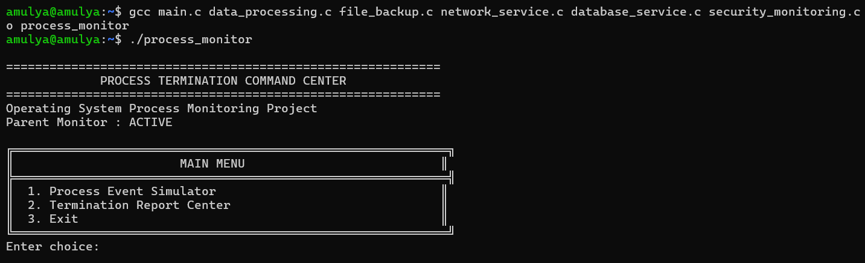

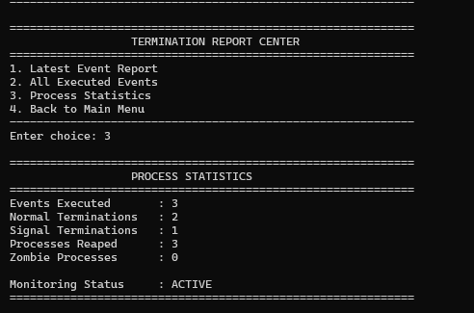

CHAPTER -6 IMPLEMENTATION

6.1 Module-wise Implementation

The Process Termination Message System is divided into separate modules, where each module performs a specific task. The modular approach makes the project easier to understand and allows each child process to perform a different practical operation. The main module controls the complete process lifecycle, while five service modules perform data processing, file backup, network operations, database operations, and security monitoring.

1. Main Process Control Module – main.c

The main.c file is the central control module of the project. It creates child processes using fork() and assigns a specific service to each child process. The parent process uses waitpid() to wait for the child process and collect its termination information.

The module checks the termination status using:

WIFEXITED() – checks whether the child terminated normally.

WEXITSTATUS() – obtains the child's exit status.

WIFSIGNALED() – checks whether the child was terminated by a signal.

WTERMSIG() – identifies the signal responsible for termination.

It also maintains event reports containing the child PID, parent PID, termination type, exit status, signal information, and reaping status.

2. Data Processing Module – data_processing.c

The data_processing.c module performs numerical data processing as a task of one child process. It creates a file containing numerical records and reads the values during execution. The module calculates the total, average, maximum, and minimum values from the records.

The calculated results are displayed and stored in data_processing_report.txt. After completing the task successfully, the child process terminates using exit(10). The parent process receives this exit status through waitpid() and reports the normal termination of the child.

3. File Backup Module – file_backup.c

The file_backup.c module demonstrates a practical file backup operation. The child process creates service_data.txt and copies its contents into service_data_backup.txt using file-reading and file-writing operations.

After copying the data, the module reads the backup file to verify that the contents were successfully copied. It also creates backup_operation_log.txt to record the backup operation. After completing the task, the child terminates normally using exit(20).

4. Network Service Module – network_service.c

The network_service.c module demonstrates basic network socket operations. The child process creates a TCP socket and attempts to connect to the localhost address 127.0.0.1 on port 8080. The result of the connection attempt is recorded in network_service_log.txt.

This module is particularly important for demonstrating abnormal process termination. After performing the network operation, the program intentionally raises the SIGTERM signal using raise(SIGTERM). As a result, the child does not complete through a normal exit() call. The parent detects this signal-based termination using WIFSIGNALED() and WTERMSIG().

5. Database Service Module – database_service.c

The database_service.c module performs database-like operations using a file named smartgym_database.txt. The child process creates records containing an ID, name, and score. It then reads and displays the records and updates one of the existing records.

The updated record is verified after the modification, and database_operation_log.txt is created to record the operation. After completing all database-related tasks, the child process terminates normally using exit(40). The parent collects and reports this termination status.

6. Security Monitoring Module – security_monitoring.c

The security_monitoring.c module performs Linux process monitoring using the /proc filesystem. The child scans the /proc directory and identifies numeric process entries to determine the number of active processes. It also obtains the current process ID and parent process ID.

The module reads process information such as the process name and generates security_monitoring_report.txt. The report contains the PID, parent PID, active process count, scan status, and monitoring status. After completing the monitoring task, the child terminates normally using exit(50).

Overall Module Execution

All five service modules are executed as child processes created by the main module. Each child performs its assigned task independently and then terminates. The parent process waits for each child using waitpid(), analyzes its termination status, displays the result, and reaps the child process. This provides a complete demonstration of process creation, task execution, synchronization, normal termination, abnormal termination, signal handling, and zombie-process prevention.

6.2 Algorithm / Pseudocode

The Process Termination Message System follows a structured algorithm in which the parent process creates multiple child processes, assigns different tasks to them, monitors their execution, and collects their termination information. Each child performs its respective service and terminates either normally or abnormally. The parent uses waitpid() to synchronize with the child and determine the reason for termination.

Algorithm:

Start the program.

Display the Process Termination Command Center menu.

Select an event or service to execute.

Create a child process using fork().

If the process is the child process:

Display its PID and parent PID.

Execute the selected service.

Perform the assigned task.

Terminate using the appropriate exit status.

For the network service, generate SIGTERM to demonstrate abnormal termination.

If the process is the parent process:

Store the child PID.

Wait for the child using waitpid().

Collect the termination status.

Check the returned status:

If WIFEXITED() is true, identify normal termination.

Obtain the exit value using WEXITSTATUS().

If WIFSIGNALED() is true, identify abnormal termination.

Obtain the terminating signal using WTERMSIG().

Store the termination information in the event report.

Confirm that the terminated child has been reaped.

Display the PID, termination type, exit status or signal information.

Update the process statistics and event history.

Return to the main menu or exit the program.

Stop.

Pseudocode:

START

Display Process Termination Command Center

WHILE program is running

Display main menu

Read user choice

IF user selects an event THEN

Identify selected service

child_pid = fork()

IF child_pid == 0 THEN

// Child Process

Display Child PID and Parent PID

IF event == 1 THEN

Execute Data Processing Service

exit(10)

ELSE IF event == 2 THEN

Execute File Backup Service

exit(20)

ELSE IF event == 3 THEN

Execute Network Service

Generate SIGTERM

// Abnormal termination

ELSE IF event == 4 THEN

Execute Database Service

exit(40)

ELSE IF event == 5 THEN

Execute Security Monitoring Service

exit(50)

END IF

ELSE

// Parent Process

Display Child PID

IF event == 3 THEN

Delay waiting temporarily

// Demonstrate temporary zombie state

END IF

status = waitpid(child_pid)

IF WIFEXITED(status) THEN

exit_status = WEXITSTATUS(status)

Record Normal Termination

ELSE IF WIFSIGNALED(status) THEN

signal_no = WTERMSIG(status)

Record Abnormal Termination

END IF

Mark child as REAPED

Display termination information

Update event report

Update process statistics

END IF

ELSE IF user selects reports THEN

Display latest/event history/statistics

ELSE IF user selects exit THEN

STOP

END IF

END WHILE

END

This algorithm ensures that every child process is monitored by the parent and that its termination information is properly collected. The use of waitpid() also ensures that terminated child processes are reaped, thereby preventing permanent zombie processes. The algorithm therefore covers the complete lifecycle of the child processes, from creation and task execution to termination, status analysis, synchronization, and process reaping.

6.3 Core C / C++ Implementation

The Process Termination Message System is implemented primarily using the C programming language because C provides direct access to Linux process-management functions and system-level resources. The complete application is divided into multiple C source files so that each component has a specific responsibility. The main source file, main.c, controls the overall execution, while data_processing.c, file_backup.c, network_service.c, database_service.c, and security_monitoring.c contain the individual child-process services. This structure improves the readability and organization of the program and makes each module easier to test independently.

The core process-management implementation is present in main.c. When an event is selected, the parent process calls fork() to create a new child process. The return value of fork() is used to distinguish between the parent and child. The child executes the service corresponding to the selected event, while the parent records the child PID and waits for its completion. The program therefore establishes a clear parent-child relationship, where the parent is responsible for monitoring the lifecycle and termination of the child.

Each child process performs a different practical operation. The data-processing service creates and reads numerical records and calculates total, average, maximum, and minimum

values. The file-backup service creates a source file, copies its contents to a backup file, and verifies the copied data. The network service creates a TCP socket and attempts a localhost connection. The database service creates records, reads them, updates a record, and verifies the modification. The security-monitoring service scans the Linux /proc directory and collects information about active processes. These operations ensure that every child process performs a meaningful task before termination.

The project uses different exit values to clearly identify the completion of each normal service. The data-processing service terminates using exit(10), the file-backup service uses exit(20), the database service uses exit(40), and the security-monitoring service uses exit(50). These values are collected by the parent using waitpid() and WEXITSTATUS(). As a result, the parent can determine not only which child has terminated but also the status returned by that particular service.

The network service provides a separate implementation for demonstrating abnormal termination. After performing its socket operation and logging the result, it intentionally generates the SIGTERM signal using raise(SIGTERM). The parent process detects this condition using WIFSIGNALED() and obtains the signal number using WTERMSIG(). This demonstrates that a child process can terminate for reasons other than a normal exit() call and that the parent can identify the signal responsible for the termination.

Synchronization is implemented using waitpid(), which ensures that the parent properly waits for the required child process. For the network-service event, the program temporarily delays the parent's waiting operation to demonstrate the concept of a zombie process. During this period, the terminated child can temporarily remain in the process table because its termination status has not yet been collected. Once waitpid() is executed, the parent collects the status and reaps the child, demonstrating how zombie processes are prevented through proper synchronization.

Overall, the core implementation follows a clear execution sequence: the parent creates a child, the child performs its assigned service, the child terminates, the parent waits for the child, termination status is analyzed, and the child is reaped. Through this implementation, the project provides a practical demonstration of process creation, parent-child relationships, process synchronization, normal and abnormal termination, signal handling, process monitoring, file operations, and zombie-process prevention.

6.4 Linux System Calls / APIs Used

The Process Termination Message System uses several Linux system calls and APIs to create, control, synchronize, and monitor processes. These functions provide direct interaction between the C program and the Linux operating system. The main process-management APIs used in the project are fork(), waitpid(), exit(), and signal-related functions. Additional APIs are used by individual service modules for file handling, network communication, and process monitoring.

The major system calls and APIs used in the project are:
System Call / API | Purpose in the Project
fork() | Creates a new child process from the parent process.
waitpid() | Makes the parent wait for a specific child and collects its termination status.
exit() | Terminates a child process with a specific exit status.
WIFEXITED() | Checks whether the child terminated normally.
WEXITSTATUS() | Retrieves the exit status returned by the child.
WIFSIGNALED() | Checks whether the child was terminated by a signal.
WTERMSIG() | Identifies the signal that terminated the child.
raise() | Generates a signal; SIGTERM is used for abnormal termination demonstration.
socket() | Creates a TCP socket in the network service.
connect() | Attempts to establish a connection with the localhost server.
close() | Closes the socket or opened resource after use.
opendir() / readdir() | Used by security monitoring to scan the Linux /proc directory.

The fork() and waitpid() APIs are the core of the project. After fork() creates a child, the child executes its assigned service while the parent remains responsible for monitoring it. The parent calls waitpid() to collect the child's termination status. The returned status is then analyzed using WIFEXITED(), WEXITSTATUS(), WIFSIGNALED(), and WTERMSIG(). This allows the system to clearly distinguish between normal completion and signal-based abnormal termination.

The other APIs support the practical operations performed by the child services. File-handling functions are used to create, read, write, copy, and update files; socket APIs support the network service; and directory APIs allow the security-monitoring service to inspect /proc and count active processes. The use of these Linux APIs makes each child process perform an actual task while the parent monitors its complete lifecycle.

Thus, the system calls and APIs form the foundation of the implementation and demonstrate important operating-system concepts such as process creation, parent-child communication, synchronization, exit-status handling, signal-based termination, file operations, network operations, process monitoring, and zombie-process prevention.

6.5 Process / Thread Implementation

The Process Termination Message System uses a process-based implementation rather than a thread-based implementation. The parent process creates multiple child processes using the Linux fork() system call. Each child process is assigned a specific service and performs its task independently. This implementation demonstrates important operating system concepts such as process creation, parent-child relationships, process execution, process termination, and process synchronization.

The project contains five child-process services: Data Processing, File Backup, Network Service, Database Service, and Security Monitoring. Each child performs an actual task before terminating. The data-processing service calculates values from numerical records, the file-backup service copies and verifies files, the network service performs a TCP connection attempt, the database service manages records, and the security-monitoring service scans the /proc directory for process information. This ensures that the child processes perform meaningful operations rather than only displaying predefined messages.

The parent process monitors the child processes using waitpid(). After a child terminates, the parent collects and analyzes its termination status using WIFEXITED(), WEXITSTATUS(), WIFSIGNALED(), and WTERMSIG(). Normal child processes return predefined exit values such as 10, 20, 40, and 50, while the network service intentionally generates SIGTERM to demonstrate abnormal termination. The parent records the PID, parent PID, termination type, exit status, signal information, and reaping status for each event.

The implementation also demonstrates zombie-process prevention. For the network service, the parent temporarily delays waitpid() so that the terminated child can temporarily remain as a zombie. When waitpid() is finally executed, the parent collects the child's termination status and reaps it. POSIX thread functions such as pthread_create() and pthread_join() are not used because the project specifically focuses on process-based execution and synchronization. Thus, the implementation demonstrates the complete process lifecycle from creation and task execution to termination, status collection, synchronization, and reaping.

6.6 IPC / Synchronization Implementation

The Process Termination Message System implements process synchronization to establish proper coordination between the parent process and its child processes. The parent process is responsible for creating and monitoring the child processes, while each child performs a specific service assigned by the main program. The fork() system call is used to create the child process, after which the parent and child continue their respective execution paths. The parent does not simply create the child and ignore it; instead, it maintains control over the child's lifecycle and waits for its completion. This approach demonstrates how an operating system manages relationships between parent and child processes and how synchronization is required when multiple processes are executing independently.

The main synchronization mechanism used in the project is the waitpid() function. After a child process performs its assigned operation, the parent uses waitpid() to wait for that particular child and collect its termination status. This prevents the parent from incorrectly assuming that the child has completed and allows the parent to obtain reliable information about the child's execution. The returned status is analyzed using WIFEXITED() and WEXITSTATUS() when the child terminates normally. The project uses different exit values for different services, allowing the parent to identify the result associated with each child. In this way, waitpid() provides both synchronization and termination-status collection within the application.

The project also demonstrates signal-based communication related to abnormal process termination. The network service creates a TCP socket and attempts to establish a connection with the localhost address. After performing its operation, it intentionally generates the SIGTERM signal using raise(SIGTERM) to demonstrate abnormal termination. The parent detects this condition after waitpid() returns and uses WIFSIGNALED() to determine that the child was terminated by a signal. The WTERMSIG() macro is then used to identify the signal number. This allows the parent to distinguish between a child that completed normally and a child that terminated because of an external or internally generated signal.

The project does not use traditional data-sharing IPC mechanisms such as pipes, shared memory, message queues, or named pipes because the main objective is to monitor process termination rather than exchange large amounts of data between processes. Instead, the termination status returned by the child and collected by the parent provides the required communication for the application. The parent stores important information such as the event number, child PID, parent PID, termination type, exit status, signal number, execution status, and reaping status. This information is then used by the report functions to display the latest event, maintain event history, and calculate overall process statistics. The individual child services also generate their own files and reports, providing evidence of the tasks performed during execution.

Another important part of the synchronization implementation is zombie-process prevention. Normally, when a child terminates, its process information can temporarily remain in the process table until the parent collects its termination status. To demonstrate this concept practically, the project intentionally delays the parent's waitpid() operation for the network-service event. During this short period, the terminated child can exist in a temporary zombie state. When the parent subsequently executes waitpid(), it collects the termination information and reaps the child, removing the zombie entry. Therefore, the IPC and synchronization implementation demonstrates the complete coordination process between parent and child, including process creation, task execution, termination-status communication, normal and abnormal termination detection, synchronization, and proper child-process reaping.

6.7 Memory Management Implementation

The Process Termination Message System uses the memory-management features provided by the Linux operating system through the process model. When the parent process creates a child using fork(), Linux provides the child with its own process execution environment. The parent and child processes operate independently, allowing each child to perform its assigned service without directly interfering with the memory used by the parent or other child processes. This separation provides a controlled environment for executing the different services in the project.

Each child process uses memory for storing temporary data required during its assigned operation. For example, the data-processing module stores numerical records and calculated values such as total, average, maximum, and minimum. The file-backup and database modules use buffers and variables while reading, writing, copying, and updating records. The security-monitoring module uses variables to store process information obtained from the /proc filesystem. These memory areas are used only while the corresponding service is executing, and the operating system manages the memory associated with each process.

Proper resource handling is also considered during the implementation. Files opened by the service modules are closed after their operations are completed, and the network socket created by the network service is closed after the connection attempt. The program avoids unnecessary long-term storage of temporary data in memory by writing required results and reports to files. When a child process terminates using exit() or through SIGTERM, the operating system releases the resources associated with that process after it is properly reaped by the parent.

The parent process also maintains a small report structure to store information about executed events, including process IDs, termination type, exit status, signal information, and reaping status. Since the project uses waitpid() to collect terminated child processes, the child processes are properly reaped and their associated process resources can be released by the operating system. Thus, the memory-management implementation demonstrates process memory separation, temporary data usage, resource handling, process termination, and proper cleanup while supporting the overall process-management objectives of the project.

6.8 Optional User Interface Implementation

The Process Termination Message System provides a simple terminal-based user interface to allow users to interact with the process-management application. The interface is implemented in the main.c file using standard C input and output functions. Instead of requiring the user to execute individual service functions manually, the application presents a structured Process Termination Command Center through which different events and reports can be selected. This makes the project easier to demonstrate and allows the user to observe the process-management operations directly.

The main menu provides options for executing the process simulation, accessing the report center, and exiting the application. When the process simulation is selected, the user can choose among the five available services: Data Processing, File Backup, Network Service, Database Service, and Security Monitoring. After selecting an event, the program displays information about the child process, including its process ID and parent process ID. The selected child service is then executed, allowing the user to observe the actual task performed by that process.

The interface also provides termination information after each child process completes. The parent process displays whether the child terminated normally or abnormally, along with the corresponding exit status or signal information. For the network service, the interface reports the SIGTERM-based abnormal termination. The program also indicates that the terminated child has been reaped, allowing the user to understand how waitpid() is used for synchronization and zombie-process prevention.

A report center is included to make the execution results easier to view and understand. It provides options for viewing the latest event report, complete event history, and process statistics. The displayed information includes executed events, PIDs, termination types, exit statuses, signal information, and reaping status. Therefore, the user interface acts as a simple command and monitoring layer over the core C implementation, making the project's process creation, execution, termination, synchronization, and zombie-prevention concepts easier to demonstrate during testing and project evaluation.

CHAPTER-7 EXECUTION AND DEMONSTRATION

7.1 Compilation in Ubuntu

The Process Termination Message System is compiled in the Ubuntu/Linux environment using the GCC (GNU Compiler Collection) compiler. Since the project consists of multiple C source files, all the required source files must be compiled and linked together to create a single executable application. The compilation process converts the C source code into machine-level instructions that can be executed by the Linux operating system. Ubuntu provides the required environment and standard libraries for compiling programs that use Linux process-management functions and system-level operations.

The project contains the main source file main.c along with the five service modules: data_processing.c, file_backup.c, network_service.c, database_service.c, and security_monitoring.c. These files are compiled together using GCC so that the functions defined in the individual service files can be accessed by main.c.

A typical compilation command used for the project is:

gcc main.c data_processing.c file_backup.c network_service.c database_service.c security_monitoring.c -o process_monitor

During compilation, GCC checks the source files for syntax errors, undeclared functions, incorrect statements, and other programming issues. It also links the required standard C and Linux libraries used by the project. The source files contain functions related to fork(), waitpid(), file handling, signals, sockets, and /proc directory operations, so successful compilation confirms that the required declarations and program components are correctly connected.

After successful compilation, an executable named process_monitor is generated. The application can then be started from the Ubuntu terminal using the appropriate executable command. During execution, the user can select different services from the command center and observe the creation and termination of child processes. The compilation and execution process therefore provides the necessary environment for testing process creation, child-process execution, termination-status detection, signal handling, synchronization, and zombie-process prevention.

7.2 Execution Commands

After successfully compiling the Process Termination Message System, the generated executable can be executed directly from the Ubuntu terminal. The execution process allows the user to start the command center and select different child-process services. The terminal is used as the primary interface for providing input and observing process IDs, termination information, service output, and generated reports.

The following commands can be used to compile and execute the complete project:

gcc main.c data_processing.c file_backup.c network_service.c database_service.c security_monitoring.c -o process_monitor

./process_monitor

After running ./process_monitor, the Process Termination Command Center is displayed. The user can select the required option from the menu and execute the available services. Each selected service creates a child process and performs its respective task. The parent process then waits for the child using waitpid() and displays the termination result.

The generated files can also be checked from the terminal using commands such as:

ls

cat data_processing_report.txt

cat backup_operation_log.txt

cat network_service_log.txt

cat database_operation_log.txt

cat security_monitoring_report.txt

Linux process information can be observed using:

ps

The execution commands therefore provide a simple method to compile, start, test, and verify the complete application. They allow the user to observe the actual execution of the five child services, normal and abnormal termination, process synchronization, generated reports, and zombie-process handling directly in the Ubuntu terminal.

7.3 Sample Inputs and Outputs

Sample Input:

Enter your choice: 1

Sample Output:

========================================

PROCESS TERMINATION COMMAND CENTER

========================================

1. Process Event Simulator

2. Report Center

3. Exit

Enter your choice: 1

----------- PROCESS EVENT SIMULATOR -----------

1. Data Processing Service

2. File Backup Service

3. Network Service

4. Database Service

5. Security Monitoring Service

6. Return to Main Menu

The first option opens the process event simulator, where the user can select one of the five child-process services.

Sample 2: Data Processing Service

Sample Input:

Enter event number: 1

Sample Output:

========================================

DATA PROCESSING SERVICE

========================================

Child Process ID: 2451

Parent Process ID: 2430

Records processed: 10

Total: 550

Average: 55.00

Maximum: 140

Minimum: 10

Data processing completed successfully.

Process ID: 2451

Termination Type: Normal

Exit Status: 10

Child Process Reaped: Yes

The data-processing child reads the numerical records, calculates the required statistical values, generates its report file, and terminates normally with exit status 10.

Sample 3: File Backup Service

Sample Input:

Enter event number: 2

Sample Output:

========================================

FILE BACKUP SERVICE

========================================

Child Process ID: 2452

Parent Process ID: 2430

Source file created successfully.

Backup file created successfully.

Backup verification completed.

File backup completed successfully.

Process ID: 2452

Termination Type: Normal

Exit Status: 20

Child Process Reaped: Yes

7.4 Screenshots of Execution

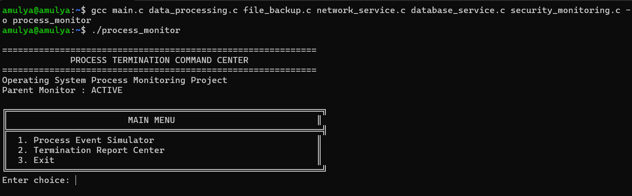

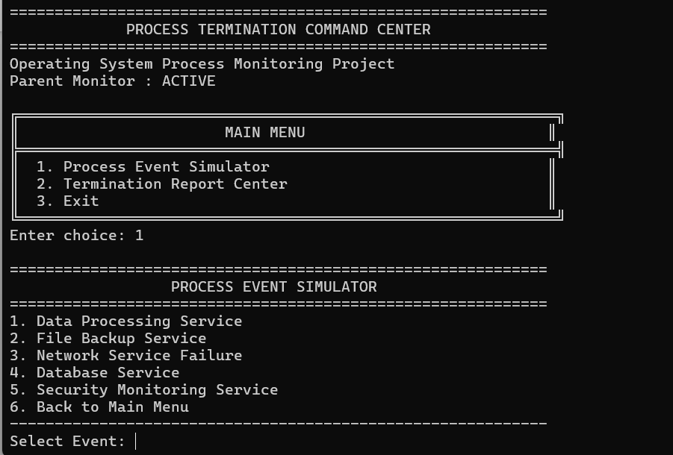

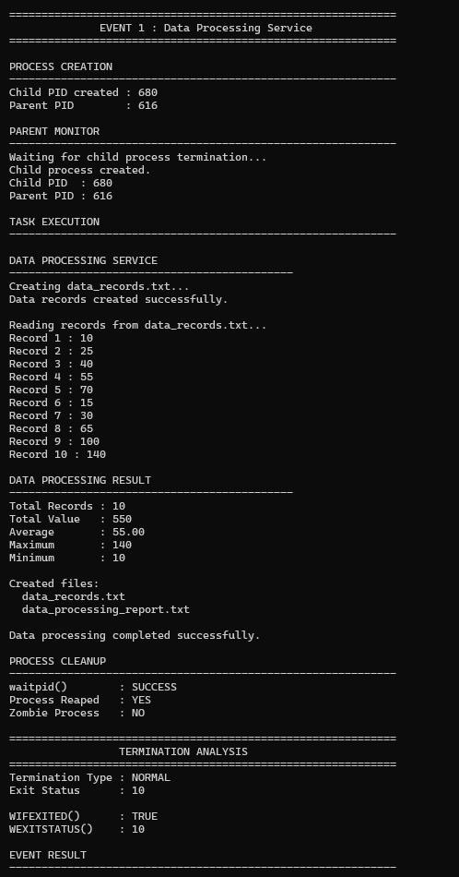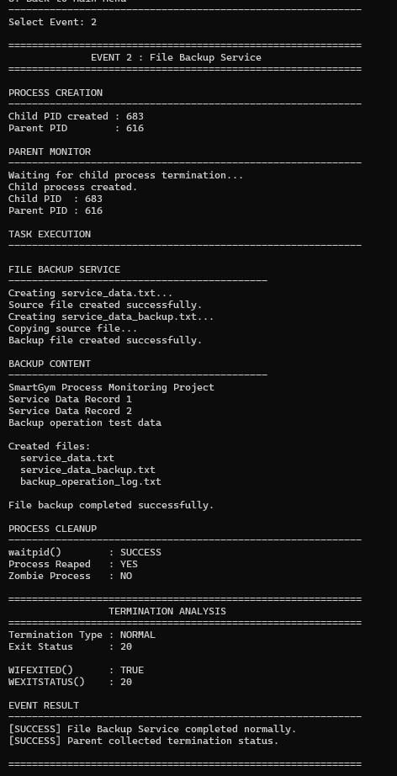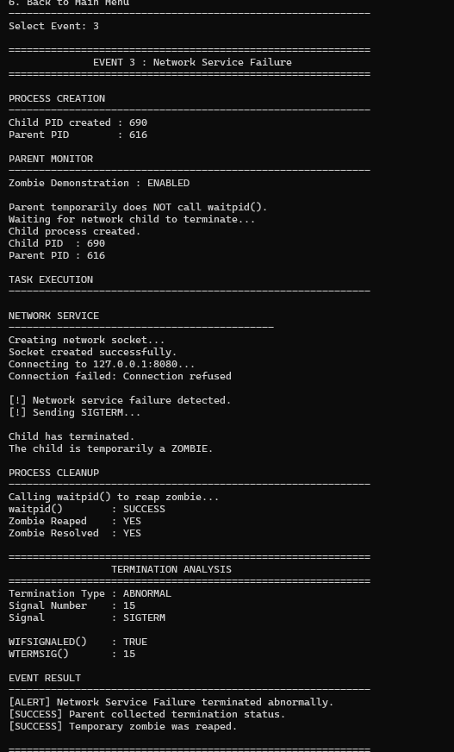

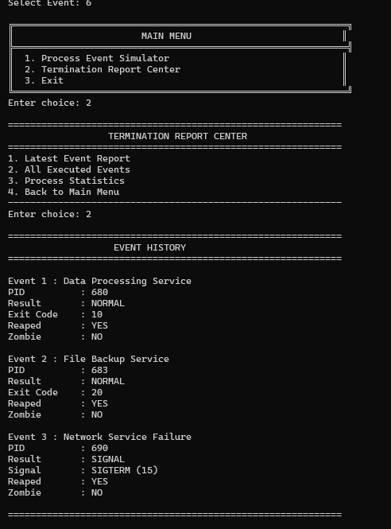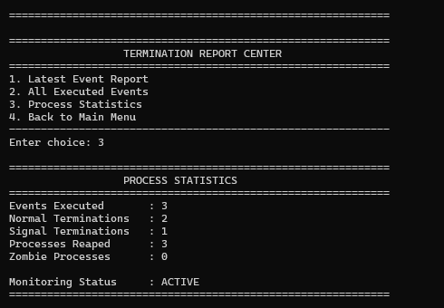

7.5 Demonstration of OS Concepts

The Process Termination Message System provides a practical demonstration of several important operating system concepts through the execution of multiple child processes. Instead of demonstrating these concepts only through theoretical examples, the project implements them directly using C and Linux system functions. The parent process controls the execution of the child processes, while each child performs a different service. This makes it possible to observe the complete lifecycle of a process from creation to termination and reaping.

The first major concept demonstrated is process creation and parent-child relationship. The fork() system call is used to create child processes from the parent process. After fork() executes, the child receives its own process ID and continues execution independently. The parent keeps track of the child's PID and remains responsible for monitoring its execution. The five child processes perform different tasks, including data processing, file backup, network operations, database operations, and security monitoring.

The project also demonstrates process synchronization and termination-status handling using waitpid(). The parent waits for the child process to terminate and then collects its termination status. The status is examined using WIFEXITED(), WEXITSTATUS(), WIFSIGNALED(), and WTERMSIG(). Normal services return predefined exit values, while the network service generates SIGTERM to demonstrate abnormal termination. Therefore, the parent can clearly determine whether a child completed successfully or was terminated because of a signal.

Another important concept demonstrated is zombie-process prevention. A terminated child may temporarily remain in the process table when its parent has not yet collected its termination status. The project demonstrates this concept by intentionally delaying the parent's waitpid() operation for the network service. After the delay, waitpid() collects the child's status and reaps the process. This shows practically how synchronization between a parent and child prevents terminated processes from remaining as zombies.

Overall, the project demonstrates process creation, parent-child relationships, process execution, process termination, synchronization, exit-status handling, signal-based termination, and zombie-process prevention in a Linux environment. The different child services make the demonstration more practical, while the reporting system displays the PID, termination type, exit status or signal, and reaping information. Thus, the project connects theoretical operating system concepts with their actual implementation in c.

CHAPTER-8 CONCLUSION

8.1 Summary of the Project

The Process Termination Message System is a Linux-based systems programming application developed using the C programming language to demonstrate important operating system concepts related to process management and termination. The primary purpose of the project is to monitor the execution and termination of child processes and provide meaningful information to the parent process. In a typical operating system, a parent process may create several child processes to perform different tasks. Once these child processes complete their work, the parent needs to know whether they terminated normally or were terminated because of a signal. The proposed system provides a practical implementation of this concept by creating multiple child processes and allowing the parent process to monitor their complete lifecycle.

The project uses the Linux fork() system call to create child processes from a parent process. After creation, each child process performs a specific service rather than simply displaying a message. This makes the project more realistic and helps demonstrate how processes can be used to perform independent tasks. The system contains five different service modules: Data Processing Service, File Backup Service, Network Service, Database Service, and Security Monitoring Service. Each service is implemented in a separate C source file and is executed by a child process according to the event selected by the user. The modular design makes the application easier to understand, test, maintain, and demonstrate.

The Data Processing Service performs numerical data processing by creating and reading a set of records and calculating values such as total, average, maximum, and minimum. The results are stored in a report file so that the output can be verified after execution. The File Backup Service demonstrates file-handling operations by creating a source file, copying its contents into a backup file, and verifying the copied data. It also generates an operation log. These two services demonstrate that child processes can perform meaningful file and data-related tasks before reporting their completion to the parent process.

The Network Service is used to demonstrate basic network-related processing and abnormal process termination. The service creates a TCP socket and attempts to connect to the localhost address 127.0.0.1 on port 8080. The result of the connection attempt is recorded in a network log. After completing the network operation, the service intentionally generates the SIGTERM signal using raise(SIGTERM). This is an important part of the project because it allows the parent process to identify a child that has terminated due to a signal rather than through a normal exit() operation. Therefore, the project provides a practical demonstration of both normal and abnormal process termination.

The Database Service performs database-like operations using a file-based approach. It creates records containing identifiers, names, and values, displays the stored records, updates an existing record, and verifies the updated information. An operation log is also generated to record the activities performed by the service. The Security Monitoring Service demonstrates Linux process monitoring by accessing the /proc filesystem. It scans numeric process entries, counts active processes, identifies the current process and its parent process, and generates a security monitoring report. These services show how child processes can interact with different operating system resources while performing independent responsibilities.

The parent process is the central component responsible for managing and monitoring all child processes. After creating a child using fork(), the parent stores the child's process ID and waits for its completion using waitpid(). This provides synchronization between the parent and child and ensures that the parent receives the termination information of the correct process. Once waitpid() returns, the parent analyzes the returned status using WIFEXITED() and WEXITSTATUS() for normal termination. If the child has been terminated by a signal, WIFSIGNALED() and WTERMSIG() are used to identify the abnormal termination and the signal responsible for it.

The project also focuses on the important operating system concept of zombie-process prevention. When a child process terminates, its termination information must be collected by the parent. If the parent does not immediately perform this operation, the terminated child can temporarily remain as a zombie process. To demonstrate this concept practically, the system intentionally delays the parent's waitpid() operation for the network service. During this period, the child can temporarily enter a zombie state. When the parent subsequently calls waitpid(), it collects the child's termination status and reaps the child. This demonstrates why proper process synchronization and child-process management are necessary in Linux.

A reporting mechanism is also included to make the process information easy to observe. The system maintains details such as the event number, child PID, parent PID, termination type, exit status, signal number, execution status, and reaping status. The application provides options for viewing the latest event report, complete event history, and overall process statistics. The terminal-based command center allows the user to select services, execute them, and immediately observe their process and termination information. The generated report and log files also provide additional evidence that the individual child services have actually performed their assigned operations.

From an operating system perspective, the project successfully demonstrates several fundamental concepts in one integrated application. These include process creation using fork(), parent-child relationships, process execution, process termination, exit-status handling, signal-based termination, process synchronization using waitpid(), and zombie-process prevention. The project also demonstrates practical use of Linux features such as file handling, TCP sockets, the /proc filesystem, and standard C libraries. By combining these concepts, the application provides a clear practical example of how a parent process can create, monitor, synchronize with, and properly manage multiple child processes.

Overall, the Process Termination Message System achieves its intended objective of providing meaningful termination information to the parent process. Instead of treating child processes as simple background tasks, the system monitors their complete execution and clearly reports whether they completed normally or terminated abnormally. The use of different child services makes the implementation practical, while the termination reports and statistics make the results easy to understand and verify. The project therefore serves as an effective academic demonstration of Linux process management and provides a strong connection between the theoretical concepts studied in Operating Systems and their practical implementation using C.

8.2 Objectives Achieved

The Process Termination Message System successfully achieves the major objectives defined for the project. The application provides a practical Linux-based implementation of process creation, execution, monitoring, termination, and synchronization. Instead of demonstrating process management only through theoretical examples, the project creates multiple child processes and assigns each process a meaningful task. The parent process continuously manages the execution of these child processes and collects useful information about their termination.

The first major objective achieved is the creation and execution of multiple child processes using the fork() system call. Five different child services have been implemented: Data Processing, File Backup, Network Service, Database Service, and Security Monitoring. Each child process performs its respective operation independently. This demonstrates the parent-child relationship and shows how different processes can be created from a common parent and assigned separate responsibilities.

The second objective of monitoring child-process termination is achieved using the waitpid() system call. The parent process waits for the required child process and collects its termination status after execution. The program uses WIFEXITED() and WEXITSTATUS() to identify normal termination and obtain the corresponding exit value. This allows the parent to determine whether a child completed its assigned task successfully and to associate the returned status with the appropriate service.

The third objective of identifying abnormal and signal-based termination is also successfully achieved. The Network Service intentionally generates the SIGTERM signal using raise(SIGTERM). The parent process detects this abnormal termination using WIFSIGNALED() and identifies the terminating signal using WTERMSIG(). This provides a practical demonstration of how an operating system can distinguish between normal process completion and termination caused by a signal.

The project also achieves the objective of preventing zombie processes through proper synchronization. The network-service event temporarily delays the parent's waitpid() operation to demonstrate how a terminated child can exist as a zombie. The parent subsequently collects the child's termination status and reaps the process. This demonstrates the importance of proper parent-child synchronization and ensures that terminated children do not remain permanently in the process table.

Another objective achieved is the generation of meaningful termination reports. The system records the event number, child PID, parent PID, termination type, exit status, signal information, execution status, and reaping status. The report center provides options for viewing the latest event, event history, and process statistics. This makes the results of the process-management operations easier to understand, verify, and present during project demonstrations.

Finally, the project successfully achieves its overall objective of providing a practical demonstration of Linux process management using C. The implementation combines fork(), waitpid(), exit statuses, signals, file operations, socket operations, and /proc process monitoring within a single application. Through these features, the project demonstrates the complete process lifecycle—from creation and task execution to termination, status analysis, synchronization, and reaping—and effectively connects operating system theory with practical systems programming.

8.3 Results Achieved

The developed Process Termination Message System successfully creates and manages multiple child processes using the fork() system call. Each child process is assigned a specific service task, including data processing, file backup, network service, database service, and security monitoring. These services perform their respective operations independently and generate meaningful outputs or reports. This demonstrates practical implementation of process creation and task execution in a Linux environment.

The system successfully monitors the termination of each child process using the waitpid() system call. After a child process completes its assigned task, the parent process collects its termination status and identifies whether the process terminated normally or abnormally. For normally completed services, the system displays the process ID and corresponding exit status such as 10, 20, 40, or 50. This provides clear information about the completion of individual child processes.

The project also successfully demonstrates abnormal process termination using signals. The network service intentionally raises the SIGTERM signal after performing its network-related operations, allowing the parent process to detect that the child was terminated by a signal rather than through normal exit. The system identifies the signal number and displays an appropriate alert message. This result proves that the application can distinguish between normal and signal-based termination conditions.

Finally, the system successfully demonstrates zombie process prevention through proper use of waitpid(). For the network service, a short delay is intentionally introduced so that the temporary zombie state can be demonstrated before the parent collects the child's status. After waitpid() is executed, the child process is reaped and the system reports that no zombie process remains. The final reports provide process IDs, parent IDs, termination types, exit or signal information, execution status, and reaping status, achieving the main objective of the project.

8.4 Skills and Learning Outcomes

The development of the Process Termination Message System provided practical knowledge of operating system concepts and Linux-based systems programming. Through the implementation of the project, the concepts studied theoretically were applied in a working C program. The project helped in understanding how processes are created, executed, monitored, terminated, and reaped by the operating system. Working with multiple child processes also provided a better understanding of the relationship between parent and child processes and how process execution can be controlled.

One of the major skills developed was the practical use of Linux system calls and process management functions. The project provided hands-on experience with functions such as fork(), waitpid(), exit(), and raise(). The use of WIFEXITED(), WEXITSTATUS(), WIFSIGNALED(), and WTERMSIG() helped in understanding how termination information is obtained and interpreted by the parent process. This improved the ability to analyze process states and determine whether a child process completed normally or was terminated because of a signal.

The project also developed programming and problem-solving skills through the implementation of different service modules. The data processing service involved file reading and calculation, the file backup service involved file copying and verification, the network service introduced socket programming and signal handling, the database service demonstrated record insertion and updating using files, and the security monitoring service used the Linux /proc filesystem to obtain process information. These activities improved skills in file handling, system-level programming, error handling, process monitoring, and resource management.

Another important learning outcome was understanding zombie process prevention and process synchronization. The project demonstrated how a terminated child can temporarily remain as a zombie until its parent collects the termination status. By using waitpid(), the parent process properly reaps the child and prevents the accumulation of zombie processes. Overall, the project strengthened practical knowledge of Linux, C programming, process management, synchronization, signals, and system-level problem solving while providing experience in developing and demonstrating an operating-system-based application.

CHAPTER-9 REFERENCES

9.1 Books

The following books were referred to for understanding operating system concepts, Linux process management, system calls, process synchronization, signals, and C programming during the development of the Process Termination Message System.

Abraham Silberschatz, Peter Baer Galvin, and Greg Gagne, Operating System Concepts, 10th Edition, Wiley.
This book was referred to for concepts related to processes, process creation, process termination, process synchronization, inter-process communication, and operating system services.

Andrew S. Tanenbaum and Herbert Bos, Modern Operating Systems, 4th Edition, Pearson.
This book was used to understand process management, parent-child processes, process states, synchronization, signals, and other fundamental operating system concepts.

W. Richard Stevens and Stephen A. Rago, Advanced Programming in the UNIX Environment, 3rd Edition, Addison-Wesley.
This reference was useful for understanding UNIX/Linux system programming, process creation using fork(), process termination, wait()/waitpid(), signals, file operations, and related system calls.

Robert Love, Linux System Programming: Talking Directly to the Kernel and C Library, 2nd Edition, O'Reilly Media.
This book was referred to for practical Linux system programming concepts, process management, system calls, signals, file handling, and interaction between C programs and the Linux operating system.

Brian W. Kernighan and Dennis M. Ritchie, The C Programming Language, 2nd Edition, Prentice Hall.
This book was used as a reference for C programming fundamentals, functions, file handling, control structures, pointers, standard libraries, and writing modular C programs.

Neil Matthew and Richard Stones, Beginning Linux Programming, 4th Edition, Wrox.
This reference helped in understanding Linux programming practices, system-level C programming, file operations, process handling, signals, and compilation and execution of programs in the Linux environment.

9.2 Research Papers

Ritchie, D. M. and Thompson, K., “The UNIX Time-Sharing System,” Communications of the ACM, Vol. 17, No. 7, pp. 365–375, 1974.
This research paper was referred to for understanding the basic design of the UNIX operating system and its process-oriented execution model. It provides important background for the Linux process-management concepts implemented in this project.

Lampson, B. W., “Hints for Computer System Design,” ACM Operating Systems Review, Vol. 15, No. 5, 1983.
This paper provides useful principles for designing reliable and manageable computer systems. The ideas are relevant to the project's approach of monitoring process execution, handling termination conditions, and providing meaningful status information.

Bach, M. J., “The Design of the UNIX Operating System,” Prentice Hall Technical Reference, 1986.
This work was consulted for understanding UNIX process structures, process states, system calls, and the relationship between processes and the operating system kernel. These concepts support the implementation of parent-child process management in the project.

Milenković, A., Milutinović, V. and Stojanović, M., “A Survey of Techniques for Improving Operating System Performance,” IEEE Computer, 1990.
This research work provides background on operating-system performance and process-management mechanisms. It helped in understanding the importance of efficient process execution and proper handling of system resources.

Barham, P., Dragovic, B., Fraser, K., Hand, S., Harris, T., Ho, A., Neugebauer, R., Pratt, I. and Warfield, A., “Xen and the Art of Virtualization,” Proceedings of the 19th ACM Symposium on Operating Systems Principles (SOSP), 2003.
This paper was referred to for broader understanding of operating-system-level resource management and isolated execution environments. It supports the study of how operating systems manage and control executing processes.

Bovet, D. P. and Cesati, M., research and technical discussions on Linux process management and kernel process structures.
These materials were useful for understanding Linux process states, process identifiers, parent-child relationships, signals, and kernel-level process handling, which are directly related to the implementation of the Process Termination Message System.

9.3 Linux / GNU Documentation

The following Linux and GNU documentation was referred to during the development and testing of the Process Termination Message System. These references were particularly useful for understanding system calls, process creation, process termination, signals, file operations, compilation, and Linux process information.

GNU Compiler Collection (GCC) Documentation – Used as a reference for compiling and linking the C source files and understanding GCC compilation options and error messages.

GNU C Library (glibc) Documentation – Referred to for standard C library functions and Linux programming interfaces used for file handling, process control, input/output, and other system-level operations.

Linux fork() Manual Page – Used to understand the creation of a new child process from the calling parent process and the return values provided to the parent and child.

Linux wait() and waitpid() Manual Pages – Referred to for understanding how a parent process waits for child-process termination, collects termination status, and reaps terminated children to prevent zombie processes.

Linux signal() and raise() Manual Pages – Used to understand signal handling and the generation of signals such as SIGTERM. These references were particularly relevant to the abnormal termination demonstration in the network service.

Linux exit() Manual Page – Referred to for understanding how a process terminates and how an exit status can be made available to the parent process through waitpid().

Linux /proc Filesystem Documentation – Used for understanding the /proc virtual filesystem and retrieving information about currently running processes. This documentation supported the implementation of the security monitoring service.

Linux Socket Programming Documentation – Referred to for functions such as socket(), connect(), and close() used by the network service to demonstrate basic TCP connection handling.

These Linux and GNU references provided the technical foundation for implementing, compiling, executing, and testing the project in the Ubuntu/Linux environment.

9.4 Online Resources

The following online resources were referred to during the development, compilation, testing, and documentation of the Process Termination Message System. These resources provided practical information about Linux commands, C programming, system calls, process management, and debugging.

Linux man-pages Project – Used to refer to detailed manual pages for Linux system calls and library functions such as fork(), waitpid(), exit(), raise(), socket(), and connect().

GNU Project – Referred to for information about GNU tools, GCC, the GNU C Library, and C programming support in Linux environments.

Ubuntu Documentation – Used for information related to the Ubuntu operating-system environment, terminal commands, package management, compilation, and execution of C programs.

Linux Kernel Documentation – Consulted for understanding Linux kernel concepts, process management, signals, the /proc filesystem, and other operating-system mechanisms.

GeeksforGeeks – Operating Systems and C Programming Resources – Used as a supplementary learning resource for understanding process creation, process states, fork(), wait(), waitpid(), signals, and zombie processes.

TutorialsPoint – Linux and C Programming Resources – Used for supplementary explanations of Linux commands, C programming concepts, file handling, and system-level programming.

These online resources supported the practical implementation of the project by providing explanations, examples, troubleshooting guidance, and technical documentation for Linux and C programming.

